REGISTER OF MERIT
What is a Merit Registry? It’s a list held by the club of exceptional Pugs. It entitles the dogs listed in the registry to add the letters ROM, SOM, or DOM to their name. This is typically done at the end of the name.
For Example: Ch. My Wonderful Pug C.D. X., ROM
Historically, ROM requirements were based solely on show performance or number of Champion progeny. While these are grand achievements it does not recognize today’s ‘complete Pug’.
Since the pug is a companion breed, excellent pugs in companionship should also be recognized. Points are separated into three categories – show, health, and performance. The basic concept is to encourage and recognize a little more than just showing. Highest wins categories are split so as to encourage participation in Pug Specialties as well as All-Breed shows. Performance events include Therapy Dog titles, obedience, and agility. By not designating a strict number of puppies it serves both small and large breeders.
It is designed so that we can recognize Pugs of Merit from the past that have greatly contributed to the breed as well as encourage current breeders/owners to strive for excellence and well-rounded Pugs. The ROM is about a collection of over and above lifetime achievements. Owners and breeders of ROM Pugs should be very proud of their achievement.
Register Of Merit (ROM)
Requires the Pug to have a total of 100 points with at least 10 points in 2 categories.

Sire of Merit (SOM)
This focuses on the puppies produced by the sire. His puppies contribute points to him. For a SOM award a Pug must have at total of 400 points with at least 50 points in 2 categories. Some dogs may not qualify for ROM but will qualify for SOM and vice-versa.

Dam of Merit (DOM)
This focuses on the puppies produced by the dam. Her puppies contribute points to her. For a DOM award a Pug must have at total of 300 points with at least 50 points in 2 categories. Some dogs may not qualify for ROM but will qualify for DOM and vice-versa.

REGISTER OF MERIT (ROM)
REQUIREMENTS AND INSTRUCTIONS:
In all cases the Pugs applying for ROM must be owned or bred by Pug Club of Canada members. These titles are lifetime awards and do not need renewing but the member must remain current. They can be granted to any Pug fitting the needed criteria, living or deceased.
For titles awarded, please include copy of each certificate (i.e. Championship Certificate).
For Highest Specialty and Highest All-Breed show wins, please include the date, show name and location, judge, and for ‘large show’ wins the number of dogs in the Toy Group/Show. Ideally a copy of the results page from the CKC should be included but the information can be validated if it occurred after 1988.
Acceptable Health clearances include CERF (or CERF exam form), OFA, OVC (or other Cdn Vet College). For Hemivertebrae (x-ray), heart, and patella a local vet exam and ‘certification’ will be acceptable (please see Veterinary Exam Form).
To apply for SOM or DOM please use the Summary Application and however many individual applications required to demonstrate the required points. Please remember that the Sire or Dams achievements do not count towards the SOM or DOM. Only the achievements of the puppies produced by them count towards the required points. You may list as many puppies as are needed to fulfill these requirements. Puppies do not have to attain ROM status for their points to count. A single puppy with a Canadian Ch. and CERF would contribute 25 points to his sire and dam but still need 75 more points to get a ROM himself. Please include copies of either litter registrations (showing sire/dam) or individual registrations to prove parentage.
Please send this package of information to the Merit Registry Chair:

Debbie Dales
42095 Husband Road
Deroche, BC
V0M 1G0
Home #: (604) 820-5000 / Cell #: (778) 554-0598
Email: cuddlepugs313@gmail.com
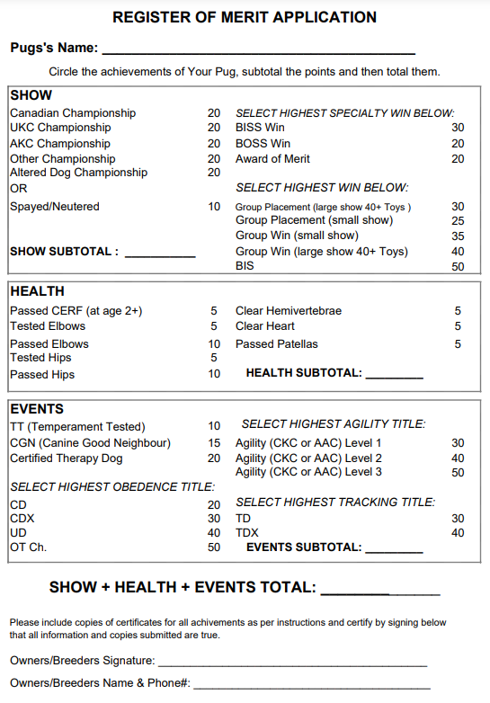
VETERINARY EXAM FORM
(For Merit Registry Application)

PUG’s NAME: ____________________________________________________

PUG’s Registration #: ______________________________________________

IDENTIFICATION (Tattoo ☐ Microchip ☐): _____________________________

Veterinarian: _____________________________________________________

Clinic: __________________________________________________________

Address & Phone: _________________________________________________

PATTELAR LUXATION:
I certify that I have examined the above-named Pug by Manual Manipulation ____ and / or Xray ____ and found no evidence of abnormal Patellar Luxation and that the Pug is over 1 year of age.

Signature & Date: _________________________________________________

HEART MURMUR:
I certify that I have examined the above-named Pug and found no indication of abnormal heart murmur and that the Pug is over 1 year of age.

Signature & Date: _________________________________________________

HEMI-VERTEBRAE:
I certify that I have examined the above-named Pug by X-ray and found no indication of hemivertebrae and that the Pug is over 1 year of age.

Signature & Date: _________________________________________________

SIRE/DAM OF MERIT (SOM/DOM)
REQUIREMENTS AND INSTRUCTIONS:

In all cases the Pugs applying for SOM/DOM must be owned or bred by Pug Club of Canada members. These titles are lifetime awards and do not need renewing but the member must remain current. They can be granted to any Pug fitting the needed criteria, living or deceased.
For titles awarded, please include copy of each certificate (i.e. Championship Certificate).
For Highest Specialty and Highest All-Breed show wins, please include the date, show name and location, judge, and for ‘large show’ wins the number of dogs in the Toy Group/Show. Ideally a copy of the results page from the CKC should be included but the information can be validated if it occurred after 1988.
Acceptable Health clearances include CERF (or CERF exam form), OFA, OVC (or other Cdn Vet College). For Hemivertebrae (xray), heart, and patella a local vet exam and ‘certification’ will be acceptable (please see Veterinary Exam Form).
To apply for SOM or DOM please use the Summary Application and however many individual applications required to demonstrate the required points. Please remember that the Sire or Dams achievements do not count towards the SOM or DOM. Only the achievements of the puppies produced by them count towards the required points. You may list as many puppies as are needed to fulfill these requirements. Puppies do not have to attain ROM status for their points to count. A single puppy with a Canadian Ch. and CERF would contribute 25 points to his sire and dam but still need 75 more points to get a ROM himself. Please include copies of either litter registrations (showing sire/dam) or individual registrations to prove parentage.
Please send this package of information to the Merit Registry Chair:
Debbie Dales
42095 Husband Road
Deroche, BC
V0M 1G0
Home #: (604) 820-5000 / Cell #: (778) 554-0598
Email: cuddlepugs313@gmail.com

SIRE/DAM OF MERIT (SOM/DOM)
SUMMARY APPLICATION

PUG Applying for SOM _____ or DOM ______:

Progeny with merit registry points, please use a single ROM sheet for each and provide all supporting documents. Submit them all together with this cover.

- ___________________________________________________________

- ______________________________________________________________________

- _____________________________________________________________________

- _____________________________________________________________________

- _____________________________________________________________________

- _____________________________________________________________________

- _____________________________________________________________________

- _____________________________________________________________________

- _____________________________________________________________________

- _____________________________________________________________________

